[**SETTING UP APPLICATION ENVIRONMENT**](https://careereducation.smartinternz.com/Student/guided_project_workspace/7918#collapse1)

# Install IBM Cloud CLI

**Step 1:**

Navigate to cloud.ibm.com

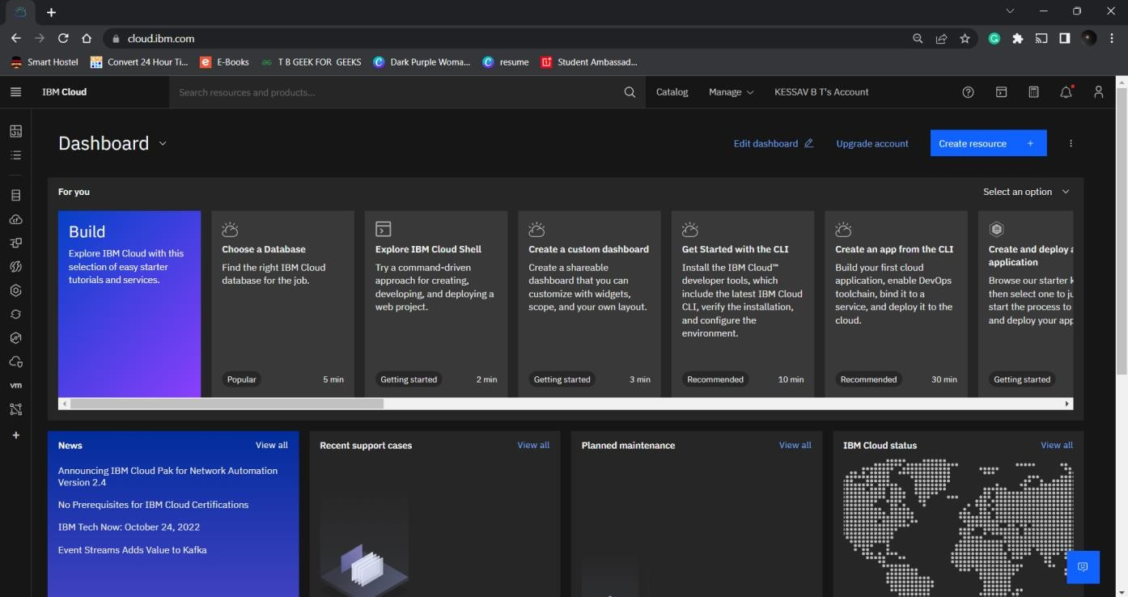

**Step 2**:

Search on Container Registry and give get started and follow the steps to install IBM Cloud CLI

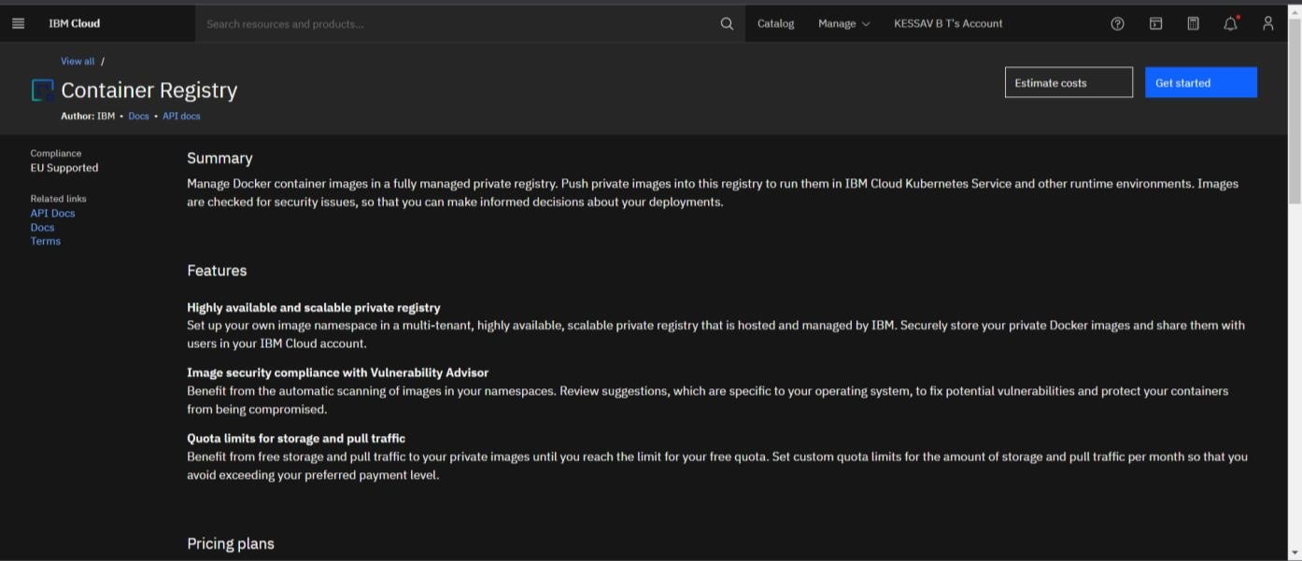

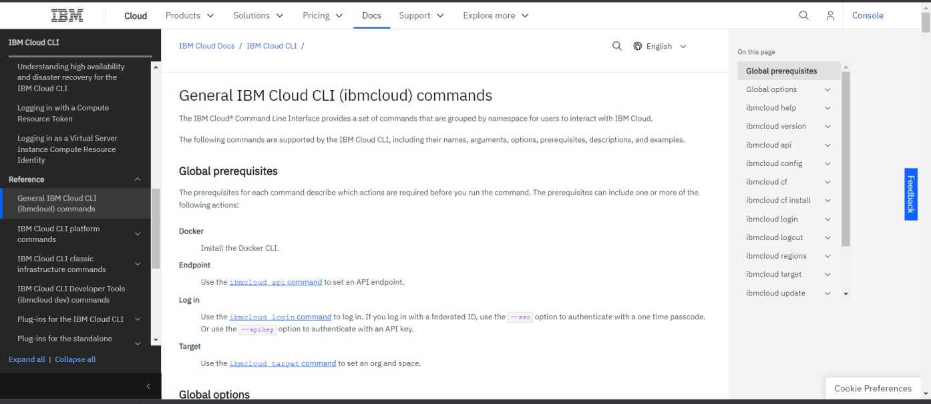

**Step 3**: Download windows 64 bit installer

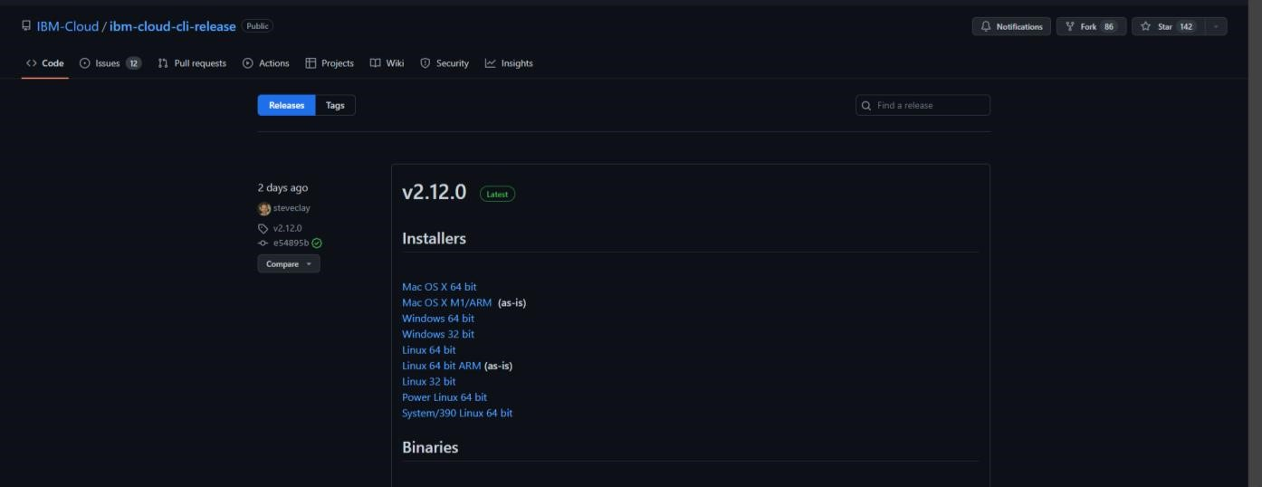

**Step 4.** Open the downloaded .exe file and run it to install IBM Cloud CLI

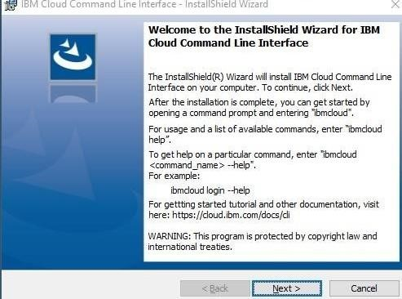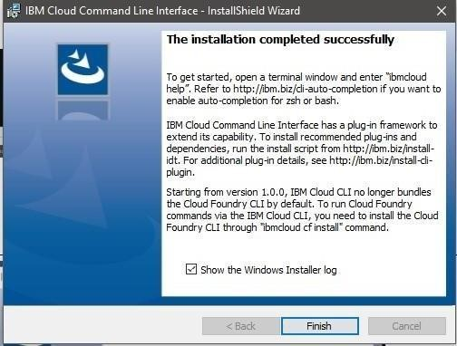

**OUTPUT**

IBM Cloud CLI is installed successfully.